
A 10

Sreenidhi Institute of Science & Technology
(An Autonomous Institution)
Code No: 104MA03

MASTER OF COMPUTER APPLICATIONS, MAY/JUNE, 2012 (Regular)
II - YEAR II - SEMESTER -- OPERATION RESEARCH (ELECTIVE - I)

Time: 3 Hours Max. Marks : 60

Note : No additional answer sheets will be provided.

Part-A (Objective Type)
Max.Marks:10

Answer all the QUESTIONS.

Part - A

1. State any two advantages of an OR model.
2. Define slack and surplus variables of a L.P.P.
3. Define a saddle point.
4. Define Bell man principle of optimality.
5. Define an assignment problem.
6. Write the condition for Degeneracy in a transportation problem.
7. Explain the concept of system reliability.
8. Name any two uses of a replacement problem.
9. Define dynamic programming.
10. Name any two applications of dynamic programming.
Part – B (Subjective Type)
Max. Marks: 50
ANSWER ANY FIVE. ALL QUESTIONS CARRY EQUAL MARKS.

1. a) What is an unbounded solution? Explain. [ 3 ]
b) Solve the following LPP by two phase method. [ 7 ]
Min z = 4x₁+2x₂+3x₃
subject to the constraints
x₁+4x₃ ≥ 5 ; 2x₁+3x₂+x₃ ≥ 4; x₁, x₂, x₃ ≥ 0
2. a) Is it required that the balanced transportation problem should be a square matrix. If so why [ 3 ]
b) Solve the following transportation problem by finding the initial basic feasible solution by VAM. [ 7 ]

 | D₁ | D₂ | D₃ | D₄
01 | 4 | 3 | 6 | 2 | 5
02 | 8 | 9 | 2 | 7 | 16
03 | 6 | 4 | 1 | 5 | 14
 | 10 | 6 | 15 | 4
3. There are five jobs, each of which must go through, the two machines A and B in the order AB. Process times are given below.
 | Processing time (hours)
Job | 1 | 2 | 3 | 4 | 5
Time for A | 5 | 1 | 9 | 3 | 10
Time for B | 2 | 6 | 7 | 8 | 4
Find the optimal sequence of the jobs and the minimum time required to process the jobs.

4. Machine A costs Rs.9,000/- annual operating costs are Rs.200 for the first year, and then increase by Rs.2,000 every year. Determine the best age at which to replace the machine if the optimum replacement policy is followed, what will be the average yearly cost of owning and operating the machine? Assume that the machine has no resale value when replaced and that future costs are not discounted.
Machine B costs Rs.10,000, Annual operating costs are Rs.400 for the first year, and then increase by Rs.700 every year. You have now a machine of type A which is one year old. Should you replace it with B, and if so, when?

5. a) Use North - West corner rule to determine an initial basic feasible solution to the following T.P.P.
 |  | A | B | C | Supply
From | A | 2 | 7 | 4 | 5
 | B | 3 | 3 | 1 | 8
 | C | 5 | 4 | 7 | 7
 | D | 1 | 6 | 2 | 14
Demand |  | 7 | 9 | 18 | 34

b) Solve the game whose pay off matrix is given by
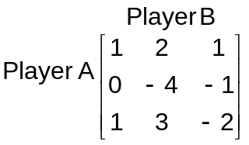

6. Calculate the EOQ in units and total variable cost for the following items, assuming an ordering cost of Rs.5 and a holding cost of 10%.
Item | Annual Demand | Unit Price
A | 800 units | 0.02
B | 400 units | 1.00
C | 392 units | 8.00
D | 13,800 units | 0.20
Also compute EOQ in rupees as well as in years of supply.

7. Find the shortest path from city 1 to city 12 through the network given below.
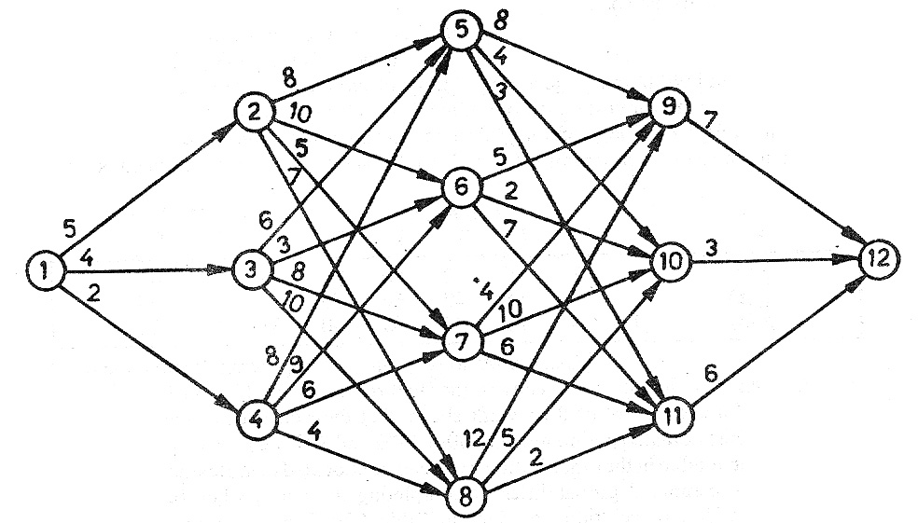
-- 00 -- 00 --

